YAI Social Network SRS

By

Itay Tur

Joni Gershberg

# Introduction

The social network project allowing people post, comment and interact with others. It’s application build by the micro-services architecture.

# Login page

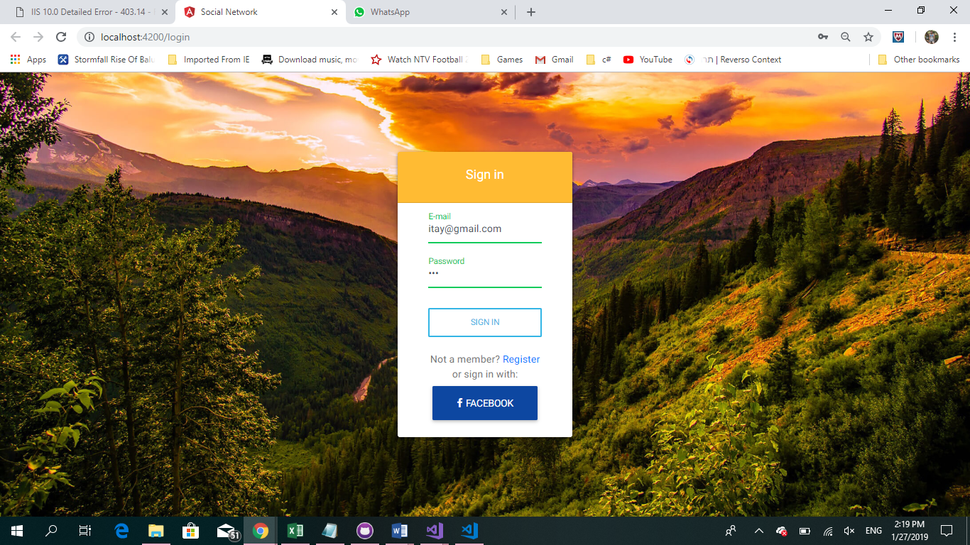

* Allowing registered users to login their news-feed of the application using facebook, or username password.
* Unregistered users be directed to the registration page.
* Validation colors and messages pop when invalid input is entered.

# Registration page

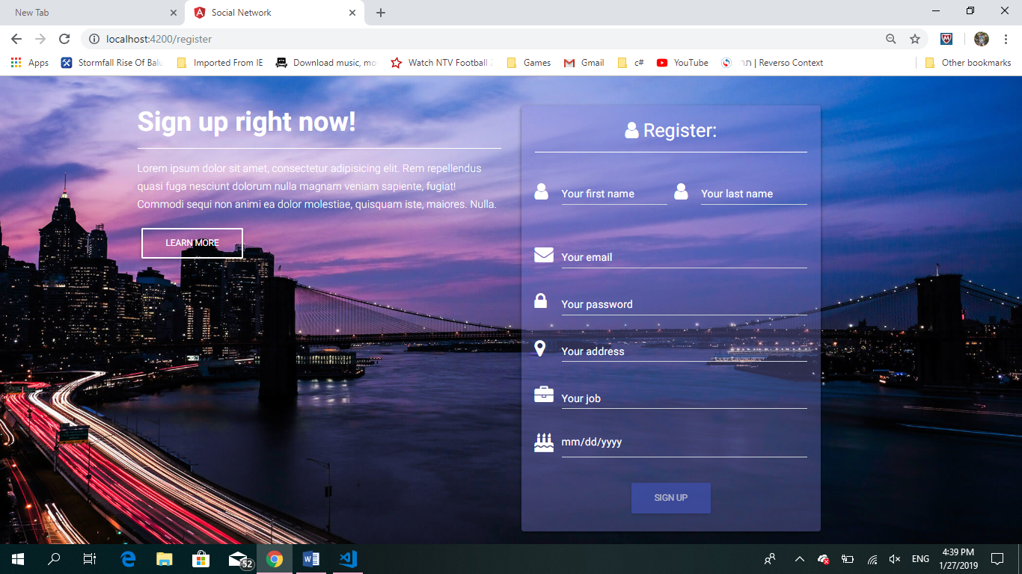

* Unregistered users can be registerd.
* Validation colors and messages pop when invalid input is entered.
* The sign-up button is enabled only when the form is valid.

# News-feed page

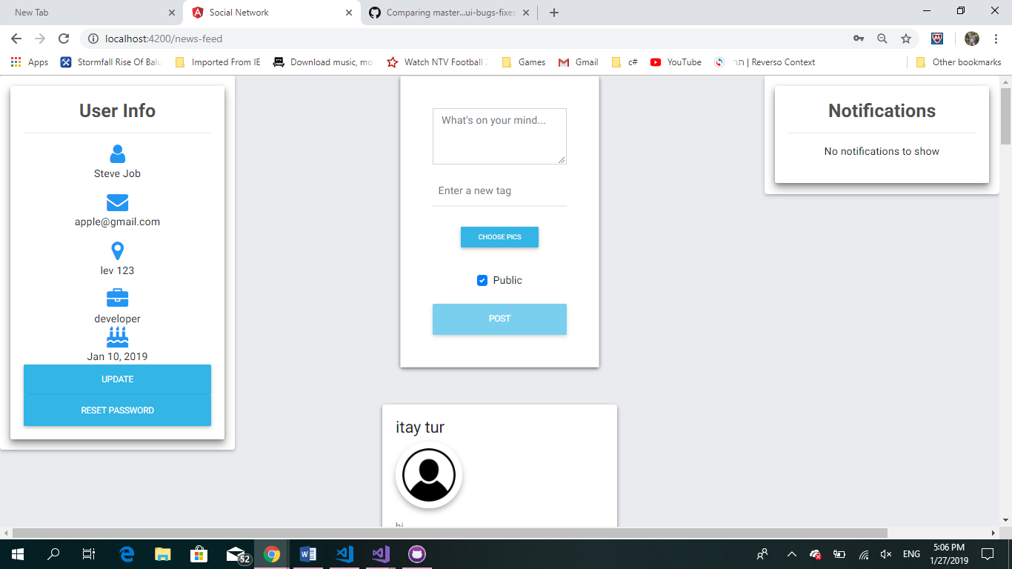

* Shows user info.
* Allow to update user info.
* User registered with username and password can reset their password.
* Users can post content, images and tag other users.
* Users can like posts and comment images, content and tag other users.
* Get notifications on activities that involve them (e.g.: they got tagged, their post got like etc.)
* Users can see their followers and users they can follow.
* Users can unfollow and block other users.
* User that get 3 blocks get blocked by the system and will be able to enter the application.

# Technologies

Need to add a table of contents or a bibliography? No sweat.

We used simpleInjector to loosely-coupled all the classes in dependency injection pattern.

The micro-services are asp.net applications. The client is made with angular.

The connection is made with HttpClient calls.

The social-server uses neo4j graph database, the auth and identity servers use dynamoDB.

Images are contained in AWS S3 storage.

Notifications are made with XMPP protocol that been implemented with ejabberd.